35.36: a) Since there is a half-cycle phase shift at just one of the interfaces, the minimum thickness for constructive interference is:
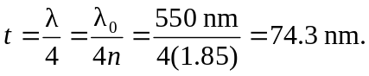
b) The next smallest thickness for constructive interference is with another half wavelength thickness added: 